**ABSTRACT**

Online Cake Ordering System is a website designed primarily for use in the cake delivery industry. This system will allow bakery and pastry shops to increase scope of business by reducing the labour cost involved. The system also allows to quickly and easily manage an online menu which customers can browse and use to place orders with just few clicks. Shop employees then use these orders through an easy to navigate graphical interface for efficient processing.

The online cake ordering system sets up menu online and the customers easily place the order with a simple mouse click. Also with a cake menu online you can easily track the orders, maintain customer's database and improve cake delivery service. This system allows the user to select the desired cake items from the displayed menu. The user orders the cake items. The payment is done through online payment or cash on delivery system. The user’s details are maintained confidential because it maintains a separate account for each user and id and password is provided for each user. Therefore, it provides a more secured ordering.

**CHAPTER 1**

**INTRODUCTION**

The OnlineCake Ordering Systemactivity is based on ordering and selling the cake for each customer. The project Online Cake Ordering System is developed to maintain and track the sales activities. It allows users to check for various cakes available at the online store and purchase online. The project consists of list of cakes and bakery products displayed in various categories. The user may browse through these items as per categories. User can pay through online payment method or cash on delivery. Once the order is confirmed, the copy of shopping receipt is generated. Thus, the Online Cake Ordering System brings an entire cake shop online and makes it easy for both buyer and seller reducing much of the paper work.

This particular system provides the benefit of the easy ordering process online from anywhere along with choices for the customers in less time and less expenditures. This latest effort will definitely usher an edge in the existing manual platform used so far for such an important aspect along with greater flexibility and sophistication in the use of the technology. Online food delivery has good scope in future in major cities. Building trust for long lasting relationship is the key to success in this industry.

With the online cake ordering method, cake is ordered online and delivered to the customer. This is made possible through the use of digital payment system. The payment can be done through the customer’s credit card or debit card. So, in this project system is designed which will allow customers to go online and place order for their cake.

As industries are fast growing, people are seeking for more ways to purchase products with much ease and still maintain cost effectiveness. The vendors need to purchase the products in order to sell to end users. The manual method of going to their local food sales outlets to purchase food is becoming obsolete and more tasking. Food can be ordered through the internet and payment made without going to the restaurant or the food vendor. So there is need for a wide range of publicity and enabling direct order, processing and delivering of food through online system. For this system, there will be a system administrator who will have the rights to enter the menu with current prevailing prices

* 1. **LITERATURE SURVEY**

In existing system for placing any orders customers have to visit cake shops to know about cake items and then place order and pay. In this method, time and manual work is required. Every shop needs certain employees to take the order in person, to offer friendly experience and process the payment. In today’s market, labour rates are increasing day by day making it difficult to find employees when needed. However, e-Menu provides additional information about menu items than a traditional paper menu. With interactive pictures it gives additional information about the food item. It makes it easier for the customer to build order and also view the most popular cakes. Moreover, various dimension filters can be used according to individual preferences e.g. price, taste, quantity, etc. In addition, this helps us in reducing running cost, enhancing service quality as well as customer relationship.

Due to the rapid growth in the use of internet and the technologies associated with it, the several opportunities are coming up on the web. So many businesses and companies are now undertaking into their business with comfort because of the internet. One of the businesses that the internet introduced is an online food ordering system. In today’s life many restaurants have focus on quick preparation and speedy delivery of orders rather than offering a rich dining experience.

The following are the references that were used in our survey

[1]IJISET - International Journal of Innovative Science, Engineering & Technology, Vol. 2 Issue 4, April 2015.

[2]. Apurva Joshi, PrachiOke, NiranjanJadhav, AshutoshBhargaveProf. Mr. S. R Lahane, “Digital Ordering System for Restaurant using Android”, in International Journal of Scientific and Research Publications, Volume 3, Issue 4, April 2013.

**CHAPTER 2**

**REQUIREMENTS ELICITATION AND ANALYSIS**

The system is made up of units that are put together to work as one in order to achieve a common goal. The requirements for the implementation of the new system are:

1)The Hardware

2)The Software

**2.1 Software Requirement**

For the effective implementation of the new system, the following software has to be installed on the computer.

**Front End**: HTML, CSS, PHP

**Back End**: XAMPP or WAMP

**Database:** Microsoft SQL (Structured Query Language) Server 2008

**IDE**: Notepad++ or NetBeans

**2.2** **Hardware Requirements**

**Processor**: Intel dual core i3, i5 or i7

**Processor Speed**: 1.0GHZ or above

**RAM**: 1 GB RAM or above

**Operating system**: Windows 7, 8, 8.1, 10

* 1. **Functional and Non-Functional Requirements**

**Functional Requirements**

A Functional Requirements defines a function of system or its component.

It includes descriptions of the data to be entered into the system, operations to be performed, work-flows and who can enter the data into system.

**Business rules:** These are intended to prevent disruption in the system or the business.

**Transaction correction, adjustments and cancellations:** The sequence of operations performed as single logic unit of work, which exhibit atomicity, consistency, isolation and durability properties.

**Administrative Functions:** In this application administrators use a specialized software to store and organize the data entered by the customers.

**Authentication:** The admin has given all the authentication to view the tables and alter the privileges of the users.

**Reporting Requirements:** This takes a copy of the essential operational data but represents it in different schema.

**Non-Functional Requirements**

**Scalability:** This application is scalable, because even adding more hardware requirements, this application linearly take more requests than before.

**Portability:** Online cake ordering system application can be run in any platform and in any system.

**Capacity:** This application has ability to handle transactional volumes which is very important for any system.

**Recoverability:** This section covers the primary elements with fast and efficient recovery from a system failure or a disaster.

**Maintainability:** This will measure the ease and speed with which a system can be restored to operational status after a failure occurs.

**CHAPTER 3**

**NORMALIZATION**

Normalization is the process of organizing the columns (attributes) and tables (relations) of a relational database to reduce data redundancy and improve data integrity. Normalization is also the process of simplifying the design of a database so that it achieves the optimal structure composed of atomic elements.

Normalization involves arranging attributes in relations based on dependencies between attributes, ensuring that the dependencies are properly enforced by database integrity constraints. Normalization is accomplished by applying some formal rules either by a process of synthesis or decomposition. Synthesis creates a normalized database design based on a known set of dependencies. Decomposition takes an existing (insufficiently normalized) database design and improves it based on the known set of dependencies.

Normalization rule are divided into following normal form.

**First Normal Form:** A relation is said to be in 1NF, if all values in given relation are atomic.

**Second Normal Form:** A relation is said to be in 2NF, if it satisfies 1NF and the non-prime attributes should be fully functionally dependent on key of relation.

**Third Normal Form:**  A relation is said to be in 3NF, if it satisfies 2NF and no non-prime attribute is transitively dependent on primary key.

**Boyce Codd normal form:** A relation is said to be in Boyce Codd normal form, if it satisfies 2NF and if and only if there are no non-trivial functional dependencies of attributes on anything other than a super key or candidate key.

**3.1 Functional Dependencies**

There is a main admin who manages the system. Admin can access the system through admin_id, admin_name and password before this admin should register into the system.

There can be one or more customers who can access the system by registering themselves with the system and login by providing cust_id, cust_name, phone and address.

Customers can place orders using order_id which contains the cust_id of the respective customer, placed_date, delivery_date and no_of_items by choosing to product.

Each item that has been ordered has an item_id, item_name, description and price given by the admin.

After the customer has placed the order, a bill is generated which has bill_id, cust_id and the amount to be paid.

Functional Dependency 1: admin_id🡪admin_name, password, phno

Functional Dependency2 :cust_id🡪cust_name,phone,address

Functional Dependency 3: order_id🡪cust_id, placed_date, delivery_date, no_of_items

Functional Dependency 4: item_id🡪order_id,item_name,description,price

Functional Dependency 5: bill_id🡪cust_id,amount

The tables that are designed, satisfies Boyce codd Normal Form and these functional dependencies.**CHAPTER 4**

**ENTITY RELATIONSHIP MODEL**

**4.1 ER Diagram**

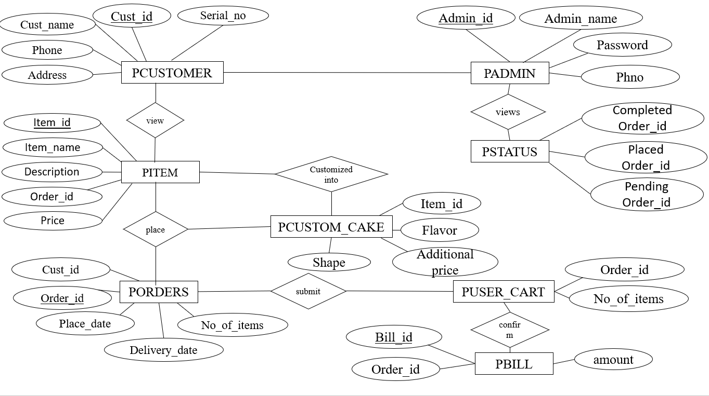

Figure 4.1

**ER Diagram Description**

The above is an Entity Relationship Diagram of Online Cake Ordering System. It consists of the following tables and their functionalities.

1. Admin: An admin can view details of all customers.
2. Customer: A customer can view any items and place order.
3. Item: There are different categories of cakes that the customer can choose.
4. Orders: Customer can place orders for any number of items required.
5. Status: It is nothing but the cart where the admin can view completed orders, placed and pending orders.
6. Bill: Finally after the customer has placed an order, a bill is generated for the total amount.

**4.2 Schema Diagram**

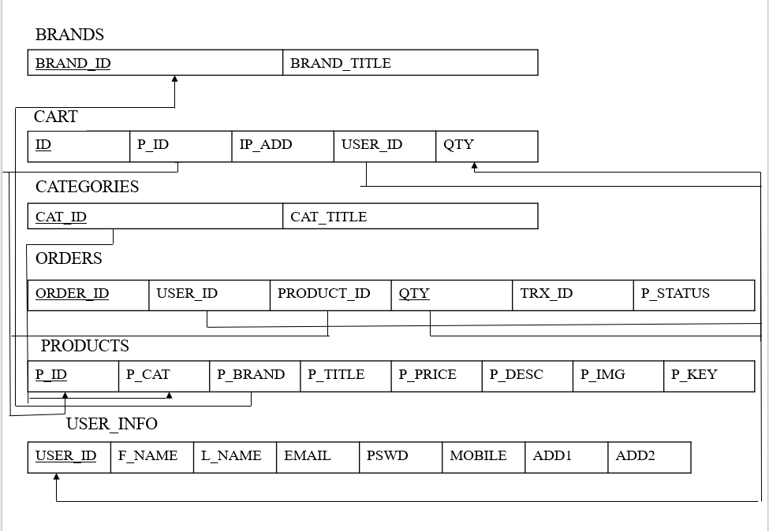

Figure 4.2

**Schema Diagram Description**

The above is a schema diagram of Online Cake Ordering System. It consists of the above mentioned tables and their attributes.

The underlined attributes are primary keys. The attributes that are linked to the primary keys are the foreign keys.

**CHAPTER 5**

**CREATION OF TABLES AND INSERTION OF VALUES**

**Brand table**

Create table brand (brand_id int,brand_title varchar(40));

Insert into brand values (‘&brand_id’, ‘&brand_title’);

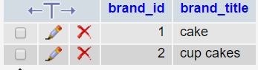

**Categories table**

Create table categories (cust_id int, cat_title varchar(40));

Insert into categories values (‘&cat_id’, ‘&cat_title’);

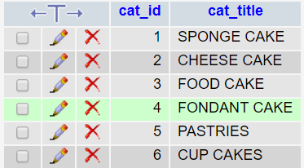

**User cart table**

Create table user_cart (order_id references porders (order_id), cust_id references customer (cust_id), no_of_items int);

Insert into user_cart values (‘&order_id’, ‘&cust_id’, ‘&no_of_items’);

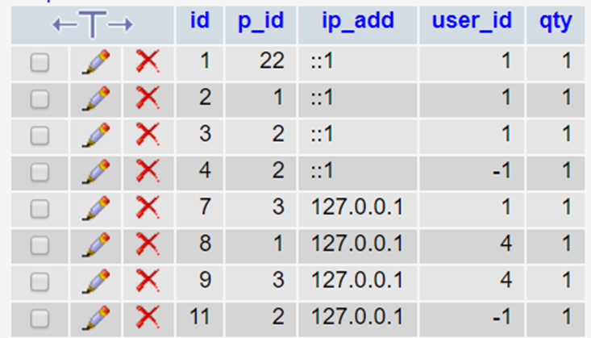

**Orders table**

Create table orders (order_id int primary key, cust_id references customer(cust_id) on delete cascade, qty int ,status varchar(10));

Insert into orders (‘&order_id’, ‘&cust_id’, ‘&qty’ , “&status”);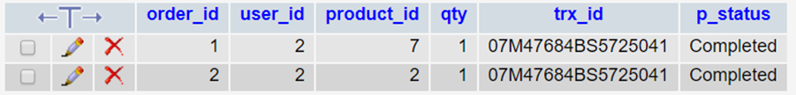

**Customer table**

Create table customer (cust_id int primary key, cust_name varchar (30), phno number (10), address1 varchar (100), address2 varchar (100));

Insert into customer (‘&cust_id’, ‘&cust_name’, ‘&email’, ‘&password’, ‘&phno’, ‘&address1’, ‘&address2’);



**Product table**

Create table product (product_id int primary key, product_cat references categories(cat_id),product_title varchar(30),product_price int, product_desc varchar(100),product_keywords varchar(30));

Insert into product(‘&product_id”, ‘&product_cat’, ‘&product_title’, ‘&product_price’,’&product_desc’,’&product_keywords’);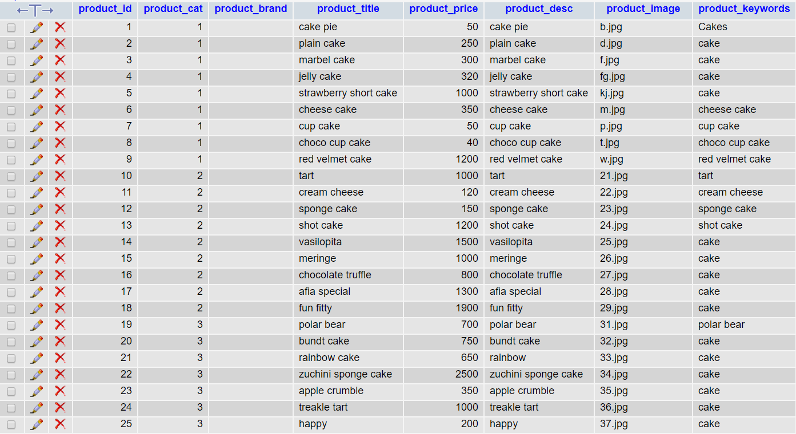

**CHAPTER 6**

**FRONT END VALIDATION AND TESTING**

**6.1 Use Case Diagram**

Figure 6.11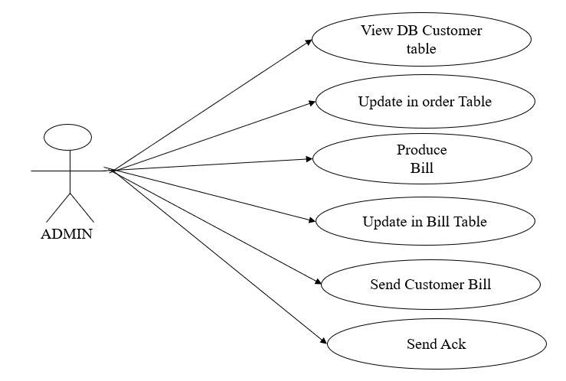

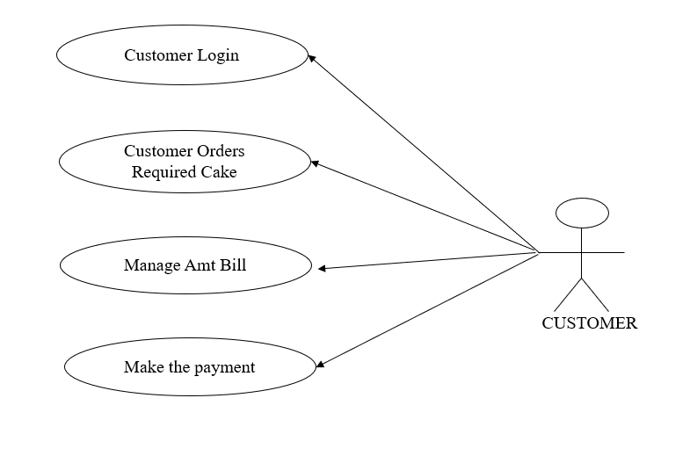

Figure 6.1

**Use Case Diagram Description**

**Admin**- an admin can view the customer table, update the table as and when new customers signup and alter the table when required. If any customer has placed an order admin will confirm the order by producing the bill. After sending the bill to the customer, admin will update the same in the bill table. After the customer has paid the amount, admin will send an acknowledge stating that the amount was received.

**Customer-** a customer can login to the system and view all the available cakes. Then the customer can place order for any cake and proceed to checkout. Then the total amount can be managed by altering the number of items required. Finally, the customer can make the payment online or through cash on delivery option.

**6.2 Sequence Diagram 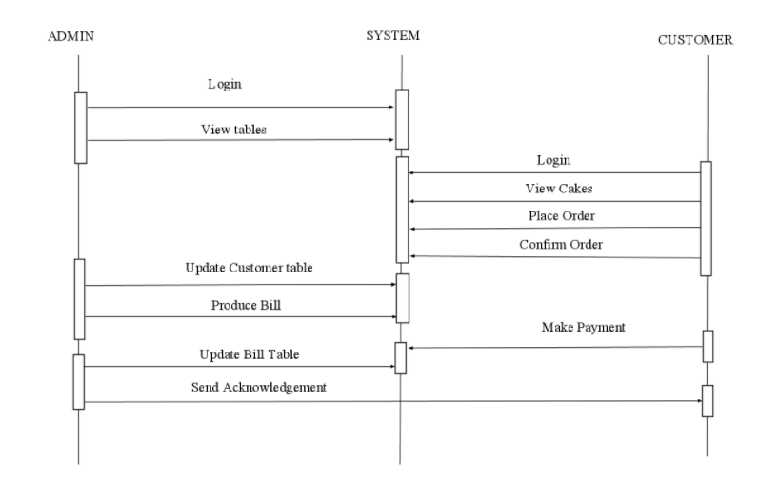**Figure 6.2

**Sequence Diagram Description**

The sequence diagram involves interaction between the admin

and the customer via system.

Admin-Here the admin will be logged in

so that there is an access to view the tables, to change the display page,

to change the authority and alter some privileges to the user.

Customer-the customer will login to the system and user will be given the

privileges to view the menu and can place the order which in turn will

be saved in the user cart. As soon he confirms his order the customer

table will be updated and produces the bill. Customer can make payment via

online payment method or cash on delivery in turn the admin will send the

acknowledgement to the customer.

**CHAPTER 7**

**SESSION PACKAGE**

**7.1 Front End**

User enters into system and views the various categories of cakes. The user can select multiple cakes and after selecting the cake it is automatically added to the user cart and the total amount is calculated for the cakes in the cart and options are provided to delete or edit cakes selected. Once finalized user can proceed with checkout by registering into the system by providing all user details and then login into the system and can proceed with payment.

**7.2 Screenshots**

**Menu**

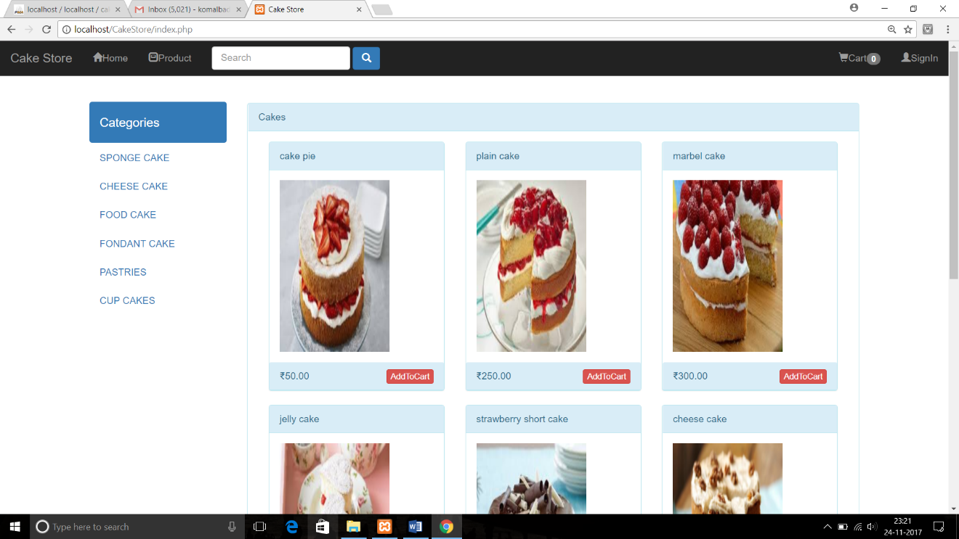

**UserCart**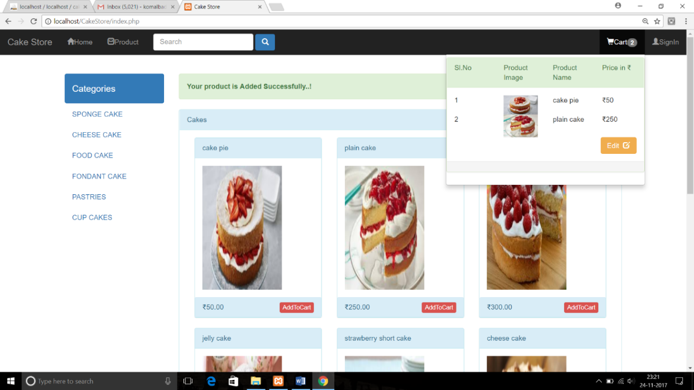

**Sign Up**

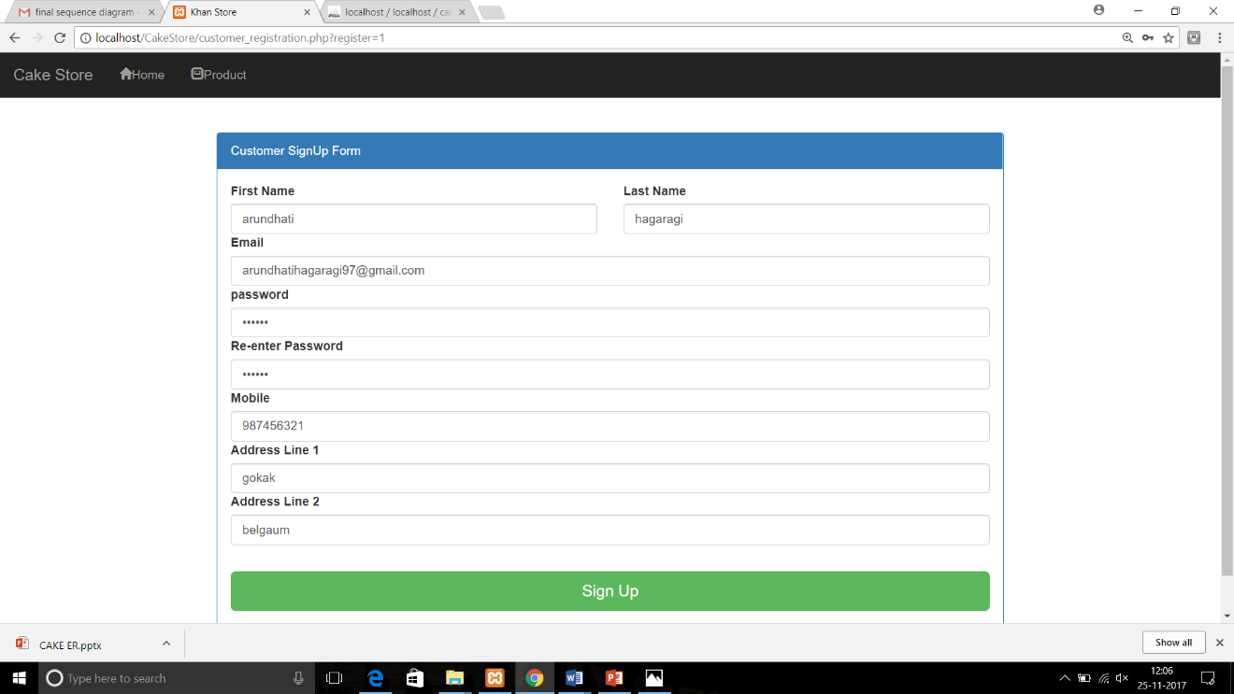

**Login**

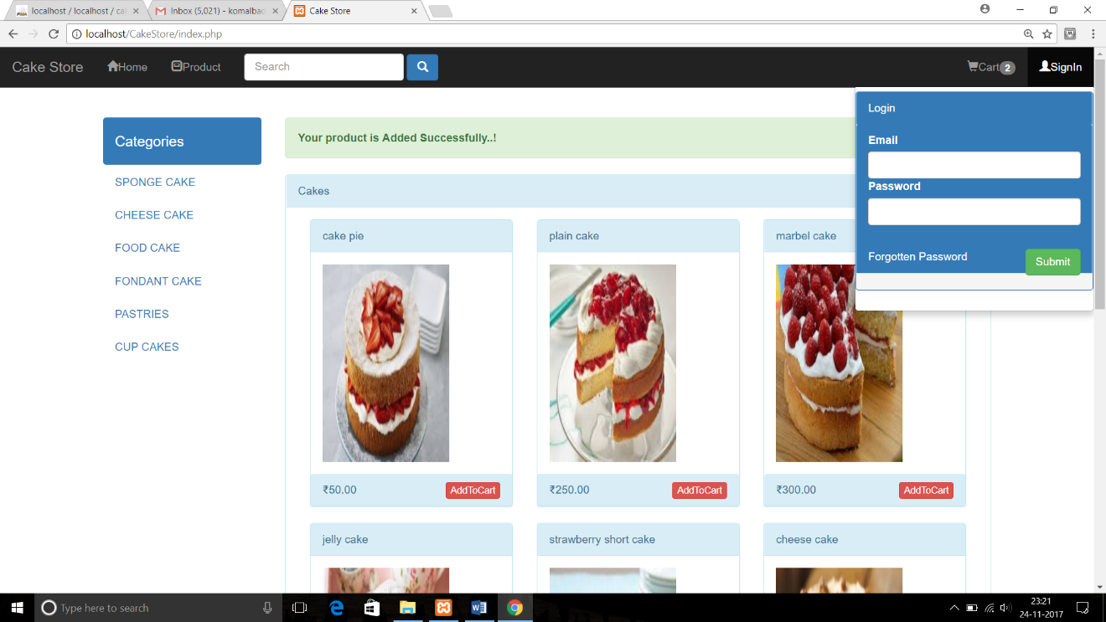

**Bill**

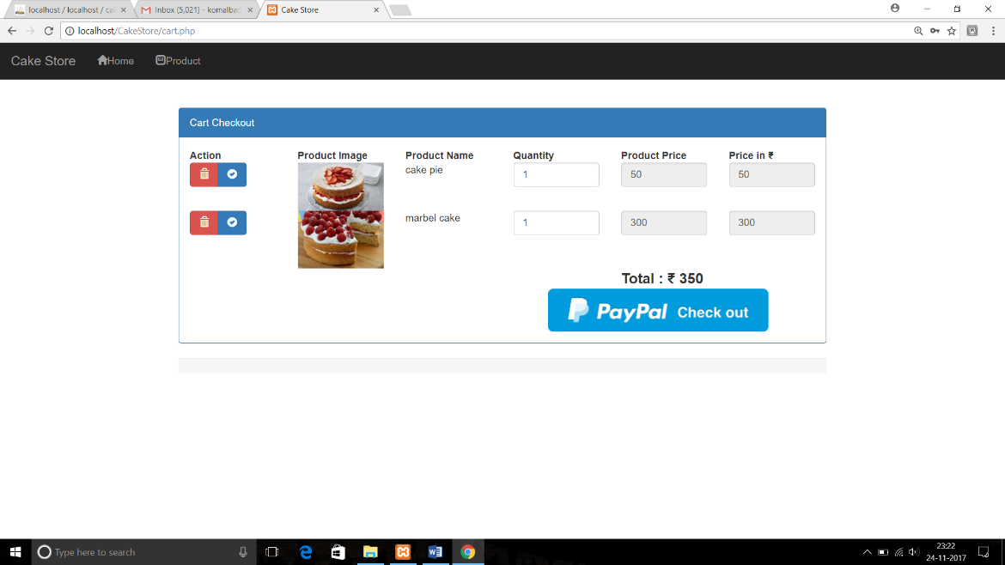

**Payment**

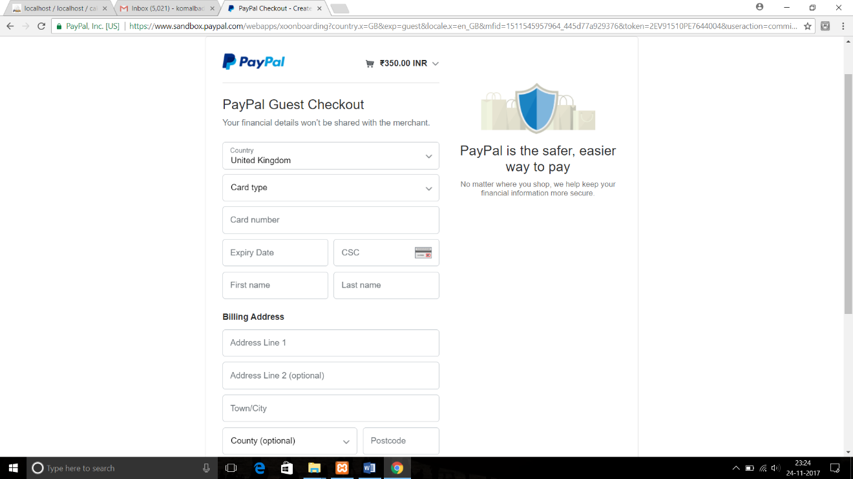

**CHAPTER 8**

**ADVANTAGES AND DISADVANTAGES**

**Advantages**

For now, only big bakeries offer online cake ordering system with highest culinary standards. With the help of this project even small bakeries will be able to provide cakes using online cake ordering system.

This project aims at sales of cake for each customer hence reducing paper work and it also provides day by day reports to keep track of all the sales activities.

Comparatively online cake ordering cost’s lesser. If you are going out in need of cakes or ordering of cakes, it may cost more compared to online cake ordering system.

Human effort or manual labour can be reduced drastically.

**Disadvantages**

Advertising and website promotion of businesses that deliver food has to be extremely cautious when it comes to maintaining and updating its websites. Updating the website is a necessity because of competition.

If customer orders the cake and if they don’t buy it or cancel the order in the last moment then it will be loss for the owners.

**CONCLUSION AND FUTURE SCOPE**

The ultimate objective of developing this system is to increase the performance of the regular employees at the shop. This approach will definitely give positive impact on the service quality provided as well as customer satisfaction. This novel approach with implementation of simple and effective technology will definitely yield the core objectives of the study.

A new type of application is proposed which greatly simplifies the ordering process for both the customer and the shop by allowing the customers to place their order online of their choice. It can prove worthy in transforming ordering processes in cake shops. The proposed system will help in reducing the long queue of people present at the shops to place orders. It helps in reducing the number of staffs used in the shop, hence will help in considerably reducing cost of shop management. It will also minimize manual service given by staff, thus eliminating the human mistakes.

**REFERENCES**

.[1].M. Firdouse Ali Khan, Swapna, ‘Design and Implementation of Ordering System for Restaurants’, in International Journal of Engineering Research & Technology (IJERT), Vol. 1, Issue 10, December- 2012. [5]. Wei Wing Chiew, Wen Jiun Yap, Soon Nyean Cheong, “Design and Development of Multi-Touchable ERestaurant Management System”, in 2010 International Conference on Science and Social Research (CSSR 2010), December 5 - 7, 2010, Kuala Lumpur, Malaysia.

[2].Ayob J., Mohd. HelmyA.Wahab, Khairunnisa K., M. IzwanAyob, M. AfifAyob, M. ErdiAyob, “The Application of Wireless Food Ordering System”, in MASAUM Journal of Computing, Volume 1 Issue 2, September 2009.

[3].Sun Guiling; Qingqing Song, "Design of the Restaurant Self-Service Ordering System Based on ZigBee Technology, “Wireless Communications Networking and Mobile Computing (WiCOM), 2010 6th International Conference on, vol., no., pp.1,4, 23-25 Sept. 2010.

[4].M.H.A. N. Ahmad, A.A. Mutalib H.A. Kadir, Wahab and M.F.M. Mohsin, “Implementation of network-based smart order system,” International Symposium on Information Technology 2008 (ITSim 2008), pp. 1-7, 2008

[5].Hashim,NikMohdZarifie and Ali,Nur Alisa and Ja'afar,AbdShukur and Mohamad, NajmiahRadiah and Salahuddin, LizawatiandIshak, Noor Asryran (2013) Smart Ordering System via Bluetooth. International Journal of Computer Trends and Technology (IJCTT), 4 (7). pp. 2253-2256

[6].M.ErdiAyob, Ayob J., Mohd. Helmy A. Khairunnisa K., Wahab, M. IzwanAyob, M. AfifAyob “The Application of Wireless Food Ordering System,” MASAUM Journal of Computing, Volume 1 Issue 2, September 2009,pp 178 -183.